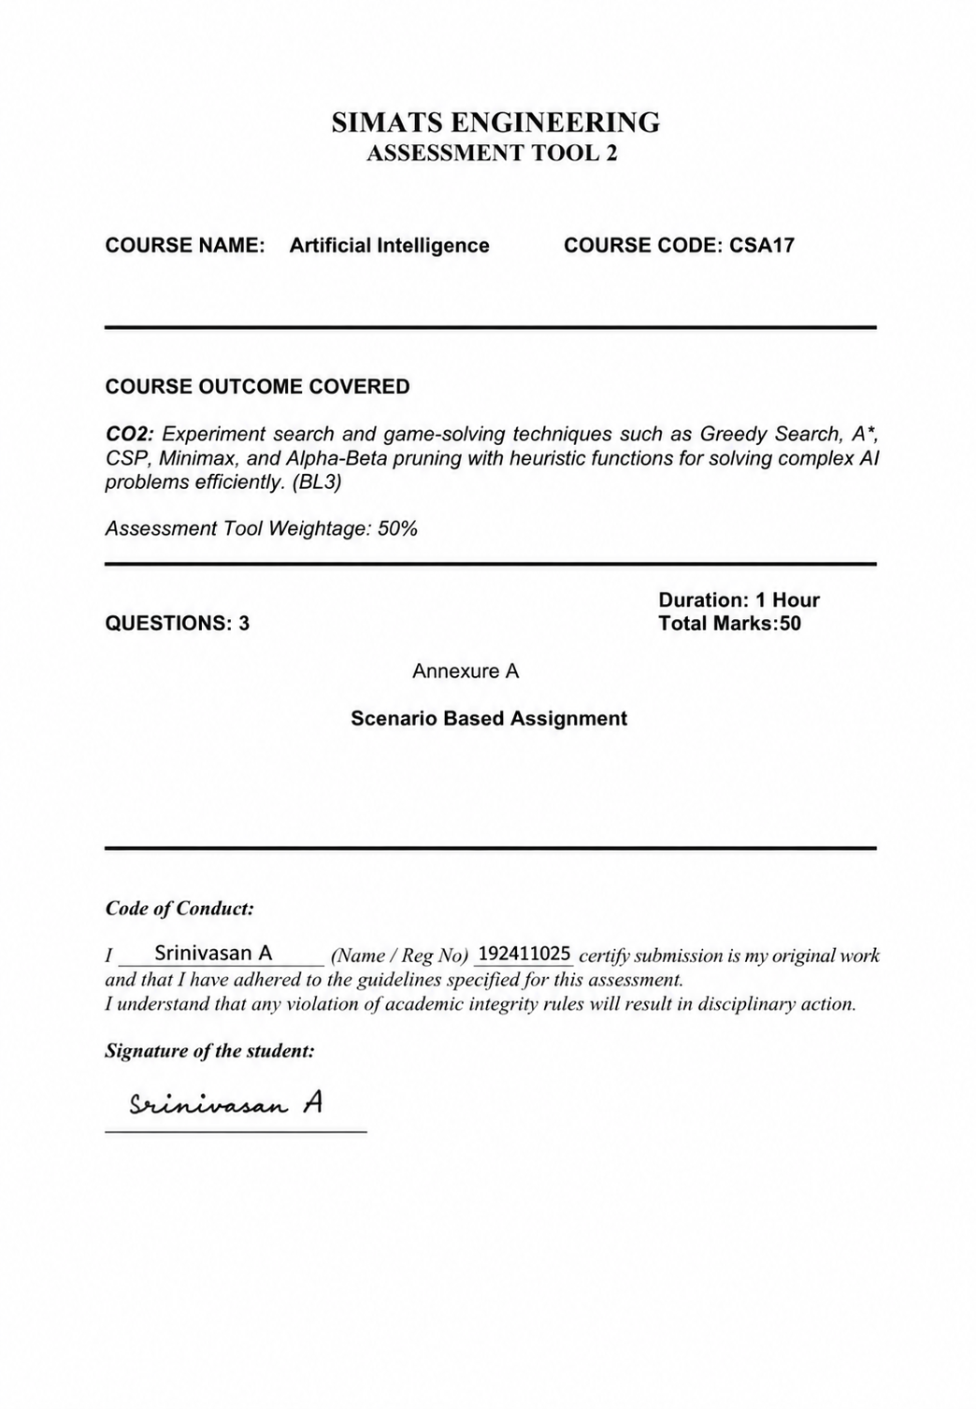

35.QUESTION
1. Scenario
A board-game company is developing an AI opponent for a turn-based strategy game similar
to checkers, to be deployed on low-power tablets. The AI must compete against human
players, make decisions within strict time limits, evaluate complex board states with multiple
possible moves, and the decision tree is extremely large, making computation expensive on
limited hardware.
Tasks:
i. Explain how the Minimax algorithm models this problem.
ii. Analyze the computational challenges of large game trees.
iii. Explain how Alpha-Beta pruning improves efficiency with detailed reasoning.
iv. Design an evaluation function and justify the factors considered.
v. Recommend a strategy for balancing optimality and real-time performance.

2. Scenario
A city&#39;s emergency dispatch center uses an AI routing system to send ambulances to accident
sites during peak-hour traffic. The environment is highly dynamic - roads may suddenly close
due to accidents or construction, and travel cost varies with congestion. The dispatch system
has access to: a heuristic estimate (straight-line distance to the incident), partial real-time

updates about road closures, and variable travel costs depending on traffic and time of day.
Because every second counts, the system must quickly decide the ambulance&#39;s route with
minimum delay and risk.
Tasks:
i. Explain how Greedy Best-First Search would behave in this scenario and discuss its
strengths and weaknesses under uncertainty.
ii. Explain how A* would handle the same situation, including how it balances cost and
heuristic.
iii. Analyze the impact of heuristic accuracy on both algorithms.
iv. Discuss how dynamic changes (sudden road closures) affect search performance.
v. Recommend the most suitable algorithm and justify your decision considering real-time
constraints, optimality, and safety.

3. Scenario
An airline implements an AI system to optimize crew scheduling across hundreds of flights
and thousands of crew members. The objective is to minimize crew costs, layover time, and
scheduling conflicts while satisfying regulatory rest requirements. The system must
continuously adjust assignments as flight delays occur. However, the search space is
extremely large, flight schedules change dynamically, and the system may get stuck in locally
optimal crew assignments.
Tasks:
Formulate this as an optimization problem and explain why traditional search is
inefficient.
i. Explain how Hill Climbing would work in this scenario and identify its limitations.
ii. Discuss issues like local maxima, plateaus, and ridges with real-world interpretation.
iii. Explain how Simulated Annealing or Genetic Algorithms can overcome these
limitations.
iv. Recommend the best approach and justify your choice based on scalability and
adaptability.

ANSWER:
1. AI Opponent for a Turn-Based Strategy Game
i. How the Minimax Algorithm Models the Problem
The Minimax algorithm is used in two-player, zero-sum games where one player's gain is the other's loss. It assumes both players make optimal decisions.
- MAX player: AI tries to maximize its score.
- MIN player: Human opponent tries to minimize the AI's score.
- The game is represented as a decision tree:
  - Nodes represent board states.
  - Edges represent legal moves.
  - Leaf nodes represent final or evaluated game states.
- The AI explores possible future moves and selects the move with the highest guaranteed outcome, assuming the opponent always chooses the best counter-move.
Example:
- AI considers Move A and Move B.
- For each move, it predicts the opponent's best response.
- The AI chooses the move whose worst possible outcome is better than the alternatives.
ii. Computational Challenges of Large Game Trees
The main challenge is the combinatorial explosion of possible game states.
Challenges
- Large branching factor
  - Every position has many possible legal moves.
  - More moves produce exponentially larger trees.
- Greater search depth
  - Looking several moves ahead multiplies the number of nodes.
- High computational cost
  - Time complexity:
[
O(b^d)
]
where:
    - b = branching factor
    - d = search depth
- Memory limitations
  - Low-power tablets have limited RAM and CPU.
- Strict response time
  - Human players expect responses within a few seconds.
  - Searching the entire tree becomes impractical.

iii. How Alpha-Beta Pruning Improves Efficiency
Alpha-Beta pruning improves Minimax by eliminating branches that cannot influence the final decision.
Alpha (α)
- Best value MAX can guarantee.
Beta (β)
- Best value MIN can guarantee.
Pruning Rule
If
[
\alpha \ge \beta
]
the remaining branch is ignored because it cannot improve the final result.
Example
Suppose:
- First branch gives AI score = 8.
- Another branch already shows opponent can force score = 5.
- If another branch cannot exceed 5, it is skipped.
Therefore,
- fewer nodes are evaluated,
- same optimal move is obtained.
Advantages
- Faster search.
- Same optimal result as Minimax.
- Allows deeper look-ahead within the same time.
- Particularly suitable for low-power devices.
In the best case:
[
O(b^{d/2})
]
instead of
[
O(b^d)
]
which is a major improvement.
iv. Evaluation Function
Since searching to the end of the game is often impossible, an evaluation function estimates board quality.
Example:
[
Score=
5(\text{Kings})
+3(\text{Normal Pieces})
+2(\text{Mobility})
+4(\text{Center Control})
+6(\text{Threats})
-5(\text{Pieces Lost})
]
Factors
1. Material Advantage
- Number of remaining pieces.
- Kings receive higher weight.
2. Mobility
- Number of legal moves.
- Greater mobility provides tactical flexibility.
3. Board Control
- Occupying central squares improves attacking and defensive options.
4. Threats
- Ability to capture opponent pieces.
5. Safety
- Avoid exposing valuable pieces.
6. Promotion Opportunity
- Pieces close to becoming kings receive bonus points.
Justification
These factors reflect long-term strategic strength rather than immediate gains alone.

v. Recommended Strategy
A practical strategy combines several techniques:
- Alpha-Beta pruning
- Depth-limited Minimax
- Good evaluation function
- Move ordering
- Iterative deepening
- Time limits
Why?
- Produces near-optimal moves.
- Meets real-time constraints.
- Works efficiently on low-power hardware.
- Improves playing strength without excessive computation.
Recommendation: Use Depth-Limited Minimax with Alpha-Beta Pruning, enhanced by iterative deepening and an effective evaluation function.
2. AI Ambulance Routing System
i. Greedy Best-First Search (GBFS)
GBFS chooses the node with the smallest heuristic value:
[
f(n)=h(n)
]
where
- h(n) = estimated straight-line distance to the destination.
Strengths
- Very fast.
- Requires relatively little memory.
- Quickly finds a route.
Weaknesses
- Ignores actual travel cost.
- Can choose roads with heavy congestion.
- May produce non-optimal routes.
- Sensitive to inaccurate heuristics.
Under Uncertainty
If a nearby road suddenly closes,
- GBFS may have to restart.
- Earlier decisions may become ineffective.

ii. How A* Works
A* evaluates nodes using
[
f(n)=g(n)+h(n)
]
where
- g(n) = actual travel cost so far.
- h(n) = estimated remaining cost.
Advantages
A* balances:
- current travel cost,
- estimated remaining distance.
It therefore avoids routes that are short in distance but expensive in travel time.
In Emergency Routing
A* naturally incorporates
- traffic delays,
- congestion,
- road closures,
- varying travel costs.
If the heuristic is admissible, A* guarantees the optimal path.
iii. Impact of Heuristic Accuracy
Accurate Heuristic
- Faster search.
- Fewer explored nodes.
- Better routing decisions.
Poor Heuristic
For GBFS:
- Can become trapped in poor routes.
- Often misses the optimal path.
For A*:
- Explores more nodes.
- Performance slows.
- Still finds the optimal solution if the heuristic remains admissible.
Thus, A* is more robust to heuristic inaccuracies than GBFS.
iv. Effect of Dynamic Road Closures
Dynamic changes require replanning.
Problems
- Previously chosen routes become invalid.
- Travel costs change continuously.
- Search may need to restart or update.
Effects
GBFS:
- Reacts quickly but may repeatedly choose poor routes.
A*:
- Better adapts because it accounts for accumulated travel cost.
- Dynamic replanning algorithms (e.g., D* Lite or Lifelong Planning A*) can further improve responsiveness in changing environments.
v. Recommended Algorithm
Comparison
Factor | Greedy Best-First | A*
Speed | Very Fast | Fast
Optimality | No | Yes (with admissible heuristic)
Handles traffic cost | Poorly | Well
Road closures | Limited | Better
Reliability | Moderate | High
Recommendation
Use A* with
- real-time traffic updates,
- admissible heuristic,
- continuous replanning (or a dynamic variant such as D* Lite).
Justification
It provides
- near-optimal travel time,
- better safety,
- adaptability,
- efficient use of heuristic information,
- reliable emergency response.
3. AI Crew Scheduling Optimization
Problem Formulation
Crew scheduling is a constraint optimization problem.
Objective
Minimize:
- crew salary cost,
- layover duration,
- idle time,
- scheduling conflicts,
- disruption caused by delays.
Subject to Constraints
- Legal rest requirements.
- Crew qualifications.
- Maximum duty hours.
- Flight coverage.
- Airport availability.
Why Traditional Search Is Inefficient
The search space contains millions or billions of possible schedules.
Traditional exhaustive search becomes infeasible because:
- exponential growth,
- many constraints,
- continuous updates due to delays,
- excessive computation time.

i. Hill Climbing
Hill Climbing starts with an initial schedule.
It repeatedly performs small improvements, such as:
- swapping crews,
- reducing layovers,
- minimizing overtime.
If a neighboring schedule is better, it moves to that schedule.
This continues until no better neighbor exists.
Advantages
- Simple.
- Fast.
- Low memory usage.
Limitations
- Can become trapped in local optima.
- No guarantee of finding the global optimum.
- Sensitive to the starting solution.
ii. Local Maxima, Plateaus, and Ridges
Local Maxima
A schedule appears optimal nearby, but better schedules exist elsewhere.
Example:
Reducing one crew's overtime may prevent discovering a larger improvement involving multiple crew swaps.
Plateaus
Many neighboring schedules have the same evaluation score.
Example:
Several crew assignments yield identical costs, leaving the algorithm with no clear direction.
Ridges
The optimal path requires several coordinated changes.
Example:
A beneficial schedule may require swapping crews across multiple flights simultaneously; changing only one assignment temporarily worsens the schedule, so Hill Climbing may not progress.
iii. Simulated Annealing and Genetic Algorithms
Simulated Annealing
Allows occasional acceptance of worse solutions.
Advantages:
- Escapes local maxima.
- Explores more of the search space.
- Gradually becomes more selective as the "temperature" decreases.
Genetic Algorithms
Maintains a population of schedules.
Operations include:
- Selection of high-quality schedules.
- Crossover to combine good features.
- Mutation to introduce diversity.
Advantages:
- Explores multiple regions simultaneously.
- Handles very large search spaces.
- Less likely to become trapped in local optima.
- Well suited to dynamic rescheduling.

iv. Recommended Approach
Comparison
Method | Scalability | Escapes Local Optima | Dynamic Adaptation
Hill Climbing | Moderate | No | Limited
Simulated Annealing | Good | Yes | Good
Genetic Algorithm | Excellent | Yes | Excellent
Recommendation
Use a Genetic Algorithm, optionally combined with local improvement methods (a hybrid or memetic approach).
Justification
- Scales effectively to thousands of crew members and flights.
- Handles complex constraints and multiple objectives.
- Explores many candidate schedules simultaneously.
- Adapts well to flight delays and changing conditions.
- Produces high-quality solutions within practical computation times, making it suitable for real-world airline crew scheduling.

